DWEG meeting 11.09.2024 - Agenda point 7 – ‘**Implementation Article 18.1 b): Member States’ data sets on information regarding risk assessment and risk management in catchment areas for abstraction points’**

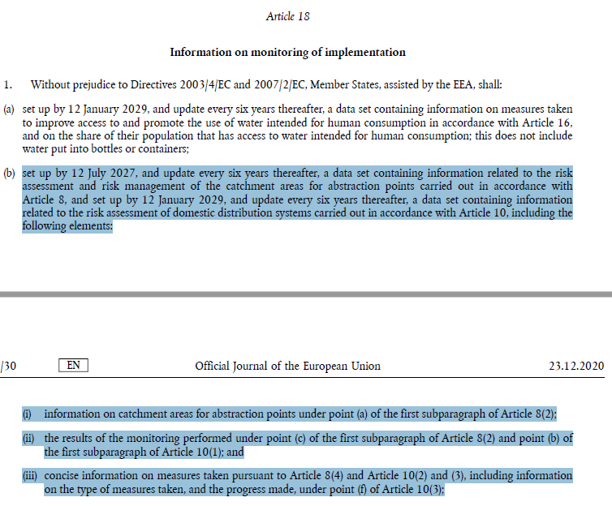

Member States have to set up a data set containing information related to the risk assessment and risk management of the catchment areas for abstraction points by 12 July 2027. In accordance with the provisions of the recast DWD, **this data set should include the following information**:

1. Mandatory: a list with unique identifiers for each catchment area for abstraction points of water intended for human consumption.
2. Optional: identifier of the corresponding water supply zone (identifier as included in the Member States’ data sets under Article 18.1 c), d) and e)).
3. Optional: identifier of the corresponding water body (identifier as included in the Water Framework Directive report)).
4. Mandatory: (links to) a map of each catchment areas and
5. Conditional: (links to) safeguard zones established under the Article 7(3) of the Water Framework Directive (WFD). [conditional because if Member States haven’t established ‘safeguard zones’, they cannot provide this information]
6. Optional: geo-references for mapped abstraction points [optional: see Article 13(1) of the Directive 2007/2/EG – INSPIRE]
7. Mandatory: a description of land-use, runoff and recharge processes
8. Mandatory: the list of parameters selected under Article 8.2(c) and their monitoring results
9. Mandatory: based on the outcome of the risk assessments carried out, an overview of the risk management measures taken by the Member States to prevent or control the risks identified, these are:
10. preventive and mitigation measures to safeguard the quality of the water not yet covered by the WFD
11. monitored parameters for substances and pollutants not yet covered by the WFD
12. evaluation of the need to establish or adapt the safeguard zones (established under Article 7(3) of the WFD) and any other relevant zones

**The collection and data treatment of this information can vary significantly in the Member States. The Commission envisages to set up a (simple) template for the Member States to transfer the MS’ data set to Reportnet3.**

**In order to set up the template, the Commission would like to receive input from DWEG members by 31 October on the format in which Member States can provide the information on each of the above points. Based on the input received, the Commission will, to the extent possible, develop a general template for the Member States’ data set transfer to Reportnet3.**